**DJANGO**

**General Request Flow:**

Once the user requests for something, it will go to DNS (domain naming system). DNS will check for the corresponding Domain name or IP address. DNS will pass the request to a web server.

The web server will route to the app server from there it will go to JNDI from there it will go to the connection pool where objects will be allocated to the requests. Each request will get assigned one object. From there, objects will assist to take the data from the corresponding database.

Web Server: web server will return the response if the request is static content like HTML.

App Server: The App server will consist of 1. Web Container 2. EJB container.

1. Web Container: It consists of servlets and JSP pages.

2.EJBContainer: It consists of enterprise java beans

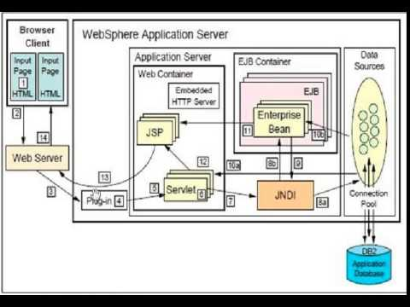

Django is a framework that is used to build apps. It uses to follow MVT model.

M stand for Model

V stands for View

T stand for Template.

**Django Advantages and Disadvantages:**

1. Implemented in Python
2. Better CDN connectivity and Content Management
3. Batteries Included Framework
4. Fast Processing
5. Offers Rapid-development
6. Scalable
7. Security

**Limitations:**

It is not suitable for smaller projects

**Request flow of Django:**

1. Once a user submits a request it will go to the Django project it will check URLs in the project folder if it is a project-level configuration.

2. If it is an app-level configuration of URLs it will go to respective apps URLS and from there it will go to Views and from there if it is a database request it will go to Model.

3. Model is connected with DB.

4. Anything related to static like HTML and CSS. It will go to templates and render the data in templates and then it will route to views and from there it will go to URLs and URLs will send back the data to the respective user by using HTTP response.

**Request and Response:**

All backend technologies and web APIs are based on one system which is The Request-Response Cycle. The system is responsible for data interchange between clients and servers. Even the new technologies based on micro-services use the Request/Response cycle.

Request / Response objects are transmitted over the web. Content like images, HTML, CSS, JavaScript is all Response Objects.

HTTP: Hyper Text Transfer Protocol is nothing but having a set of rules and standards followed by devices to transfer information via the internet.

Both the client and server are using HTTP. If both of them don't have the same protocol, the connection cannot be done.

Just like humans need to have a common language to understand each other. In the same way, various computers and machines over the internet need to have the same protocol. At least the one through which they communicate.

Response

Request

The requests are smaller in size than the response. A Request is a "request made by the client" to the server. Any URL that gets searched is a request.

Below is the sample request.

http://localhost:8000

here HTTP is the protocol and localhost will act as a domain name and 8000 will port number.

Requests are smaller compared to Responses as responses consist of HTML and CSS, JavaScipt, image, and video files.

Usually, responses will be provided by the servers and the response consists of different parts.

HTTP headers are used to contain various information regarding the response.

We can consider that header info as Meta Data. Metadata use to tell the browser from where the request came and what type of data it contains.

Django is an application that resides in a server and its main task is to process the request received by the server then it calls the functions and provides a response.

Generally, requests and responses are handled by middleware in Django.

Whenever a request comes it will call security middleware first if the middleware is unhealthy it won't allow going further.

If it allows the request to go further and later time Authentication middleware will come into the picture.

Authentication middleware won't know how to handle unhealthy requests.

Once our request passes all the middleware it will go to the URL router, URL router simply extracts the URL from the request and it will try to match it with the request in the URLs, which we use to provide in the URL.py file.

Once, we get a matching URL, the corresponding view function is called. The view function will get various attributes and other URL parameters. Also, the view function will be able to access files from the requests. These Requests are considered to be HttpRequest class objects.

Once, the view function has been executed, it's time to give a response. The response is given in the form of HttpResponse. The response is not limited to that. The Response can be PDF, JSON, or CSV. That is one of the features of Django. It provides built-in support to respond to various types.

If the response is rendered it will look for the HTML and then the HTML file will be processed by the Django Templating Engine and the response will be sent, which consists of HTML and other static content which is requested by the requester.

**Cookies:**

Whenever we request something it uses to take every request as new so that it causes issues like user login and authentication, these problems will be solved by cookies.

Cookies are small text files that are created and maintained by your browser on the particular request of Web-Server. They are stored locally by the browser, and most browsers will also show the cookies generated in the Privacy and Security settings of the browser.

Suppose, you are logging in to any website, that website will respond to the browser with some cookies which will have some unique identification of the user-generated by the server and some more details according to the context of the website.

Cookies made these implementations possible with ease which was previously not possible over HTTP implementation.

When the initial request comes the server used to send the response with some cookies along with the requested content and from next time onwards whenever the user makes a new request along with the request browser will send cookies.

This process will be repeated until cookies expire or Session is closed. Post session closes cookies will auto delete by the browser itself.

Different websites are using different cookies depending on their requirements. In general, cookies get generated whenever we use to log in any sites are online shopping apps like Amazon and Flipkart.

In Django, we can create the cookies by using the below method.

set_cookie()

The set method has attributes like names and values.

**name:** It specifies the name of the cookie.

**value:** It specifies the text or variable you want to store in the cookie.

**max_age:** It is the period of the cookie in seconds. After the mentioned time over cookie will expire. It is an optional parameter, if this parameter we didn't give that time cookie will be active until we close the browser.

There few drawbacks to cookies, Cookies are not using HTTPS protocol, and cookies are plain text in nature, it is not safe to keep important info that can be easily hacked by hackers.

As cookies are stored in the local browser users will get the prompt to store the data or not. Many websites are sending cookies with the accept or decline promptly.

**Sessions:**

To overcome the drawbacks of cookies web developers come up with a solution called sessions.

Which is more secure.

The session uses two-way communication between the browser and the server. Whenever the client request something session will get created with a session ID which is unique and it will not change until the session gets to finish.

In Django, we use middleware and an inbuilt app that will help you generate these session IDs.

**Cache:**

Caching is the process of storing the data which is recently generated so that we can use that data shortly when requested again. We can remove the cache whenever we want.

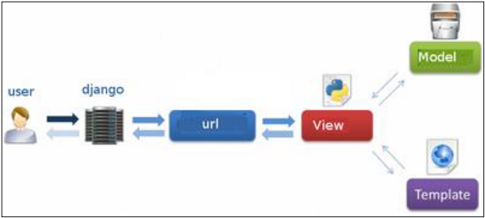

**Architecture of Django**

**High-level steps we are performing in Django:**

1. Create a project

2. Create App

3. Start App

4. Create a template folder

5. Create a subfolder inside the template folder

6.Create HTML file

7. Create a database

8. Write a class in the model which fields you want in the database table.

9. Edit the HTML file with the required fields of a database.

10. Import model in views by model class name.

11. Create a static folder inside create another folder called image and then place the images required for the website here.

12. Edit settings file with required parameters like Database and Static and Templates Installed Apps.

**Commands to create a Django project:**

>mkdir folder name

Go inside the folder

>Django-admin startproject projectname

Start the Django Project

>python manage.py run the server

Create App:

>python m

anage.py startapp appname

1. init file àby seeing this we can understand the folder is a Django project.

2. Settings fileà It contains config settings to connect DB and Middleware

* Apps details
* Middleware details
* Templates
* WSGI APP config
* Databases

3. urlsà It carries a URL pattern. Web pages or view URLs will configure here.

4. wsgiàWeb Server gateway interface àit is used to deploy our applications to online servers or cloud servers (We use this file on prod deployments)

5. manage. pyàit is useful while doing migrations

The Default Django port number is 8000

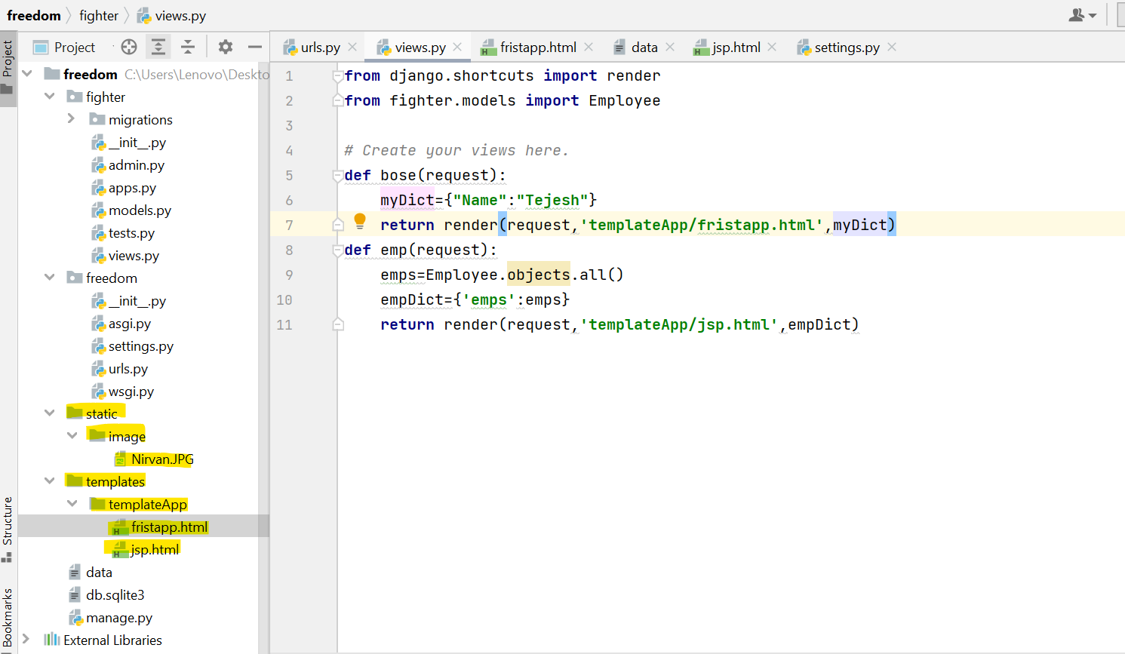

**Configurations in the Settings file**: from pathlib import Path

import os

import operating system is used to communicate from python to System.

# Build paths inside the project like this: BASE_DIR / 'subdir'.

BASE_DIR = Path(__file__).resolve().parent.parent

In the above field, BASE_DIR will take the absolute path of the project.

DEBUG = True

We should not use this option in production as

INSTALLED_APPS = [

"django.contrib.admin",

"django.contrib.auth",

"django.contrib.contenttypes",

"django.contrib.sessions",

"django.contrib.messages",

"django.contrib.staticfiles",

"app1",

]

We have to add created app name in the settings->Installed Apps.

In the above example, we have added "app1" which we created earlier.

MIDDLEWARE:

It is a frame or a plugin that takes an incoming request and manipulates it (makes some required changes) and sends it to the view.

It can also work on templates like once the view process everything and middleware can manipulate and process and send it back to views.

MIDDLEWARE = [

'django.middleware.security.SecurityMiddleware',

'django.contrib.sessions.middleware.SessionMiddleware',

'django.middleware.common.CommonMiddleware',

'django.middleware.csrf.CsrfViewMiddleware',

'django.contrib.auth.middleware.AuthenticationMiddleware',

'django.contrib.messages.middleware.MessageMiddleware',

'django.middleware.clickjacking.XFrameOptionsMiddleware',

]

Security Middleware(Django.middleware.security.SecurityMiddleware) :

It is responsible for HTTPS or SSL support and other security features.

Session Middleware (django.contrib.sessions.middleware.SessionMiddleware) :

It helps us to manage the sessions, it is responsible for taking the incoming request and making sure if the session is active and the response goes to the web browser that time cookies will be created. Common Middleware(Django.middleware.common.CommonMiddleware):

It works on URLs; it checks any forward slash at the end of the URLs if any issues with that it will resolve them.

CSRF Middleware(Django.middleware.csrf.CsrfViewMiddleware):

If the form is submitted it checks for a CSRF token if that is not there it will throw an error.

Authentication Middleware(django.contrib.auth.middleware.AuthenticationMiddleware) :

Authentication middleware is responsible for authenticating the end user request. It will also make sure there is an object available for the views and the template once the authentication happens.

Above is the default middleware which is provided by Django. We won't change this existing middleware. We will create our custom middleware to interrupt the incoming request and do some changes depending on the requirements like encrypt or zip.

How to create custom middlewares:

__init__, __call__ are mandatory inbuilt methods in every middleware which we are creating.

process_view, process_exception, and process_template_response methods are inbuilt optional while creating our custom middleware. In the below example, we are explaining how we can declare these methods in a class.

Example:

MyMiddleware

__init__(self,get_response)

__call__(self,request)

Process_view(self,request,view_func,view_args,view_kwargs)

Process_exception(self,request,exception)

Process_template_response(self,request,response)

Once view sends the request,

First, it will call __to init__ method and it will go to" Security Middleware", Once it is done it will point to the next middleware "Session Middleware". Once Session Middleware did it will point to Common Middleware,

After Common Middleware it will points to CSRF Middleware finally it will go to Authentication Middleware.

Once all the above middleware gets complete Django will hand over the request to view itself.

­­­­­­__call__ method is invoked before it calls the next method or after the response is processed and just before the response goes back to the client.

**Process_view:** This Method has direct access to the view function and its arguments can change and manipulate if required usually we won't do that. Within this method, we will add extra logic like unzip, zip, Encrypt, Decrypt

**Process_Exception:** We can handle the exceptions that are raised within our application. It has access to the request and exception that has been raised.

**Process_template_response:** This method will be invoked just before the template response is sent to the client it has access to request and response.

**Creation of Middleware:**

create a file with middleware.py and write a class with required methods like __init__.

**Class Middlewarelife:**

def __init__(self,get_response):

self.get_response=get_response

def __cell__(self,request):

print('Before the view is executed')

response=self.get_response(request)

print('after the view is executed')

return response

Custom middleware that we have created will be configured at the end of the middleware section in the security.py file. After this middle, if there is any other middleware, the request will go to that (get response points to the next middleware). if the created customized middleware is the last in the settings file, it will go to the view itself.

Exception handling exception:

TEMPLATES = [

{

"BACKEND": "Django.template.backends.Django.DjangoTemplates",

"DIRS": [os.path.join[Base-Dir,'templates']],

"APP_DIRS": True,

"OPTIONS": {

"context_processors": [

"django.template.context_processors.debug",

"django.template.context_processors.request",

"django.contrib.auth.context_processors.auth",

"django.contrib.messages.context_processors.messages",

],

},

},

]

DATABASES = {

"default": {

"ENGINE": "django.db.backends.sqlite3",

"NAME": BASE_DIR / "db.sqlite3",

}

}

If you want to use the default database as your database then we no need to perform any modifications. If not, we can specify our database and we can mention the DB name below.

Ex: 'ENGINE': 'django.db.backends.Mysql',

'NAME': 'tejesh',

'USERNAME': 'root',

'PASSWORD':'Admin@123'

Static:

STATIC_URL = 'static/'

STATICFILES_DIRS=[os.path.join(BASE_DIR,'static')]

Here we use to provide a Base directory path and static as a parameter to identify where the static file exists.

CRUD Operations: An admin user can perform the below operations by logging in to

C-create: The ability of the application to store data in the database.

R-read: The ability of the application to read data from the database.

U-update: The ability of the application to edit the stored value in the database.

D-delete: The ability of the application to delete the value in the database.

We are going to develop the operations in the same order.

The majority of applications on the internet are CRUD applications

CRUD operations on function-based views.

Creating a new project to perform CRUD operations.

1. creation of a virtual environment.

2. Install Django

3. Create the Django project

4. Installing Application and Other Important Settings

5. Create Models

6. Create Views

7. CRUD operations on tables using ORMS

Example program:

Settings.py:

from pathlib import Path

import os

# Build paths inside the project like this: BASE_DIR / 'subdir'.

BASE_DIR = Path(__file__).resolve().parent.parent

# Quick-start development settings - unsuitable for production

# See https://docs.djangoproject.com/en/4.1/howto/deployment/checklist/

# SECURITY WARNING: keep the secret key used in production secret!

SECRET_KEY = 'django-insecure-=m-32%_g@agdwr=ji2u!!ls+90d#vdg@tcur7i0#++j^zvf6%c'

# SECURITY WARNING: don't run with debug turned on in production!

DEBUG = True

ALLOWED_HOSTS = []

# Application definition

INSTALLED_APPS = [

'django.contrib.admin',

'django.contrib.auth',

'django.contrib.contenttypes',

'django.contrib.sessions',

'django.contrib.messages',

'django.contrib.staticfiles',

'fighter'

]

MIDDLEWARE = [

'django.middleware.security.SecurityMiddleware',

'django.contrib.sessions.middleware.SessionMiddleware',

'django.middleware.common.CommonMiddleware',

'django.middleware.csrf.CsrfViewMiddleware',

'django.contrib.auth.middleware.AuthenticationMiddleware',

'django.contrib.messages.middleware.MessageMiddleware',

'django.middleware.clickjacking.XFrameOptionsMiddleware',

]

ROOT_URLCONF = 'freedom.urls'

TEMPLATES = [

{

'BACKEND': 'django.template.backends.django.DjangoTemplates',

'DIRS': [os.path.join(BASE_DIR,'templates')],

'APP_DIRS': True,

'OPTIONS': {

'context_processors': [

'Django.template.context_processors.debug',

'Django.template.context_processors.request',

'Django.contrib.auth.context_processors.auth',

'Django.contrib.messages.context_processors.messages',

],

},

},

]

WSGI_APPLICATION = 'freedom.wsgi.application'

# Database

# https://docs.djangoproject.com/en/4.1/ref/settings/#databases

DATABASES = {

'default': {

'ENGINE': 'Django.db.backends.mysql',

'NAME': 'empdb',

'USER':'root',

'PASSWORD':'Admin@123'

}

}

# Password validation

# https://docs.djangoproject.com/en/4.1/ref/settings/#auth-password-validators

AUTH_PASSWORD_VALIDATORS = [

{

'NAME': 'django.contrib.auth.password_validation.UserAttributeSimilarityValidator',

},

{

'NAME': 'django.contrib.auth.password_validation.MinimumLengthValidator',

},

{

'NAME': 'django.contrib.auth.password_validation.CommonPasswordValidator',

},

{

'NAME': 'django.contrib.auth.password_validation.NumericPasswordValidator',

},

]

# Internationalization

# https://docs.djangoproject.com/en/4.1/topics/i18n/

LANGUAGE_CODE = 'en-us'

TIME_ZONE = 'UTC'

USE_I18N = True

USE_TZ = True

# Static files (CSS, JavaScript, Images)

# https://docs.djangoproject.com/en/4.1/howto/static-files/

STATIC_URL = 'static/'

STATICFILES_DIRS=[os.path.join(BASE_DIR,'static')]

# Default primary key field type

# https://docs.djangoproject.com/en/4.1/ref/settings/#default-auto-field

DEFAULT_AUTO_FIELD = 'Django.db.models.BigAutoField'

Views:

from Django. shortcuts import render

from a fighter. models import Employee

# Create your views here.

def bose(request):

myDict={"Name":"Tejesh"}

return render(request,'template app/firstapp.html',myDict)

def emp(request):

emps=Employee.objects.all()

empDict={'emps':emps}

return render(request,'templateApp/jsp.html',empDict)

def createEmp(request):

form = EmployeeForm()

if request.method =='POST':

form = EmployeeForm(request.POST)

if form.is_valid():

form.save()

return redirect('/')

return render(request,'templateApp/create.html',{'form':form})

def deleteEmp(request,id):

emp=Employee.objects.get(id=id)

emp.delete()

return redirect('/')

HTML file1:jsp.html

HTML in Templates

<!DOCTYPE html>

<html lang="en">

<head>

<meta charset="UTF-8">

<title>Employee</title>

</head>

<body>

<h1>Emp List:</h1>

{% if emps %}

<table>

<thead>

<th>firstName</th>

<th>lastName</th>

<th>sal</th>

<th>email</th>

</thead>

{% for emp in emps %}

<tr>

<td>{{emp.firstName}}</td>

<td>{{emp.lastName}}</td>

<td>{{emp.sal}}</td>

<td>{{emp.email}}</td>

</tr>

{% endfor %}

</table>

{%else%}

<p>No records found</p>

{% endif %}

</body>

</html>

HTML file 2: create.html

<!DOCTYPE html>

<html lang="en">

<head>

<meta charset="UTF-8">

<title>Create</title>

</head>

<body>

<h1>Create Employee</h1>

<form method="post">

<table>

{{form.as_table}}

{%csrf_token%}

</table>

<br/>

<input type="submit" name="" value="save">

</form>

</body>

</html>

Form:

from Django import forms

from fighter.models import Employee

class EmployeeForm(forms.ModelForm):

class Meta:

model=Employee

fields='__all__'

Admin.py

from Django. contrib import admin

from fighter.models import Employee

# Register your models here.

class EmployeeAdmin(admin.ModelAdmin):

list_display = ['firstName','Lastname,'sal']

admin.site.register(Employee,EmployeeAdmin)

URLS:

from Django.contrib import admin

from Django.URLs import path

from fighter import views

URL patterns = [

path('admin/', admin.site.urls),

path('p/', views.bose),

path('q/',views.emp)

]

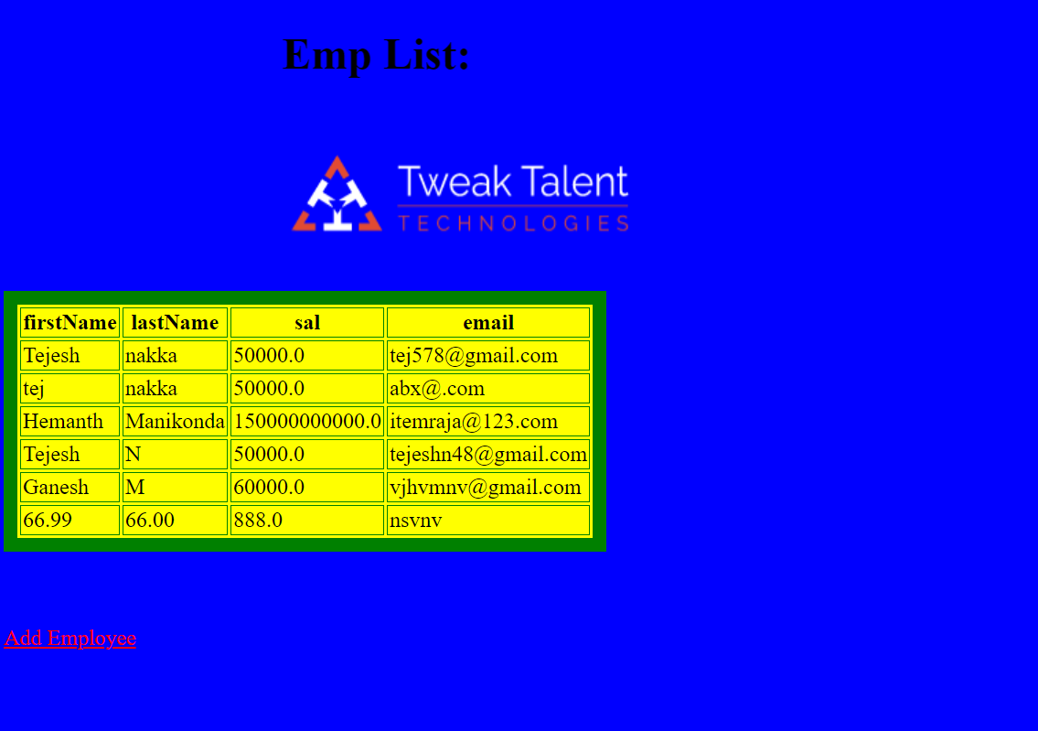

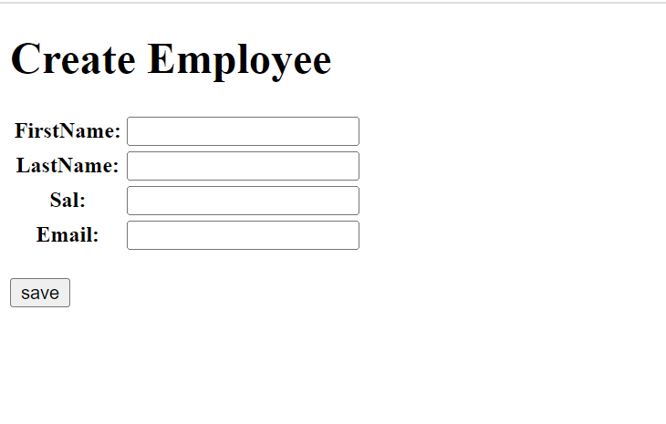

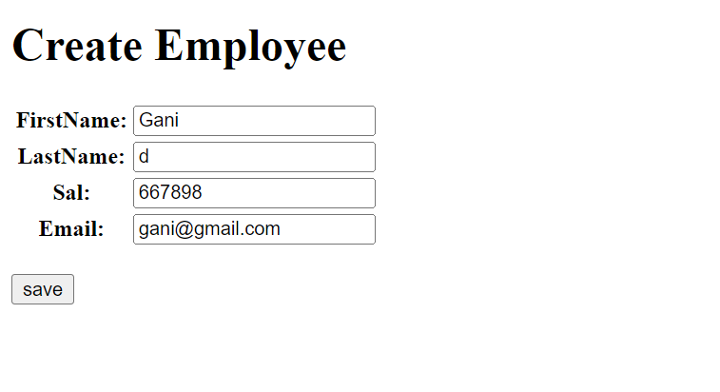

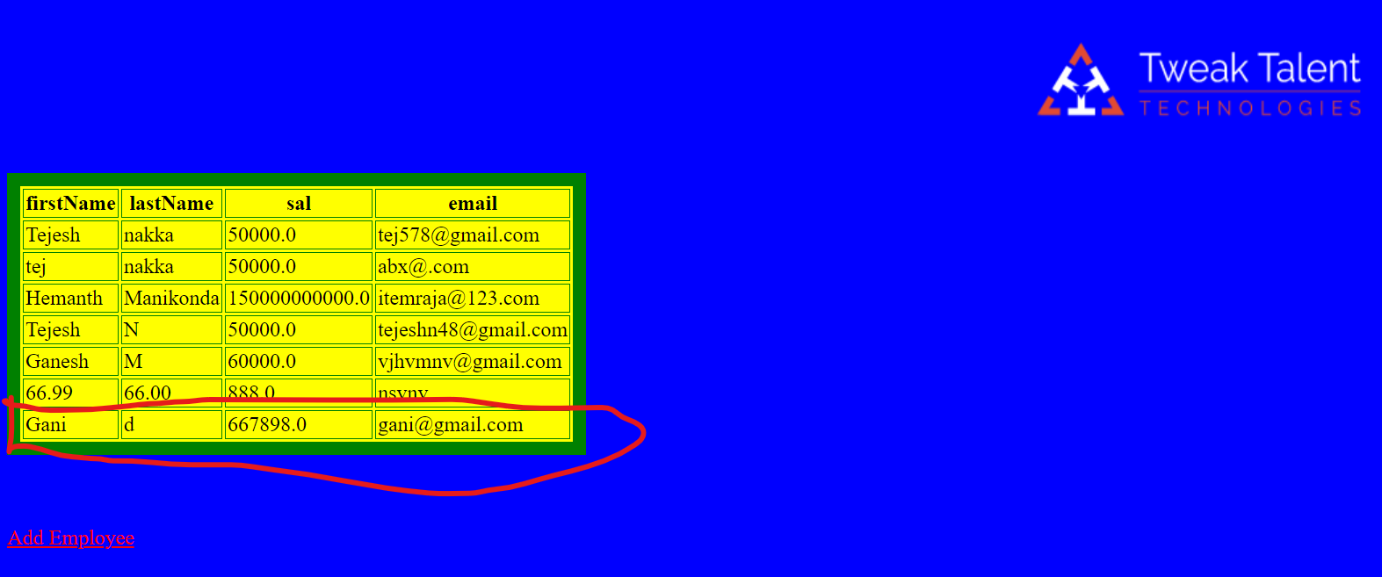

1. In the above example we have created a database called empdb, and the required fields of the database like first name and last name, sal, and email, we have placed in the class of models.py file.

2. We have written a function in views to get all objects in the model and render with empdb.

3. In the Html file called JSP we have created it under Templates\templateApp\jsp.Html. In jsp.html we have created a table and mentioned database field names.

4. After the above steps we made migrations and performed all migration steps for the fields we have mentioned in the models.

5. Post these fields will create in the table.

6. For insertion of the data we have created the form and to redirect to the form from the actual tables page we have given hyperlinks by using an anchor tag in Html.

7. To create a form we have created an empty file in the form file we have imported forms from Django.

8. Import models of the app with a class name.

9. Create a class and take the metadata from the model with all fields.

10. Provide context root and corresponding view name (along with function name).

Delete:

We have added delete in existing HTML like below.

<img src="{%static "image/Nirvan.JPG" width="104" height="142"%}"/>

After HTML now it's time to create views for the delete operation.

**ORM:**

Django lets us interact with its database models, i.e. add, delete, modify and query objects, using a database-abstraction API called ORM (Object Relational Mapper). This article discusses all the useful operations we can perform using Django ORM.

For demonstration purposes, we will use the following Django models.

Example1:

from Django.db import models

# Create your models here.

class Employee(models.Model):

firstName=models.CharField(max_length=30)

lastName=models.CharField(max_length=30)

sal=models.FloatField()

email=models.CharField(max_length=100)

def __str__(self):

return self.title

Example2:

from django.contrib.auth.models import User

from Django.db import models

payment_choices = (

('UPI', 'UPI'),

('CC', 'Credit Card'),

('DC', 'Debit Card'),

('COD', 'Cash On Delivery'),

('APB', 'Amazon Pay Balance'),

)

class Product(models.Model):

name = models.CharField(max_length=15)

price = models.FloatField()

description = models.CharField(max_length=100)

variants = models.CharField(max_length=5)

items_available = models.IntegerField()

def __str__(self):

return self.name

class Cart(models.Model):

user_id = models.ForeignKey(User, on_delete=models.CASCADE)

product_id = models.ForeignKey(Product, on_delete=models.CASCADE)

class Order(models.Model):

user_id = models.ForeignKey(User, on_delete=models.CASCADE)

billing_address = models.CharField(max_length=50)

delivery_address = models.CharField(max_length=50)

payment_type = models.CharField(max_length=10, choices=payment_choices)

class OrderProduct(models.Model):

order_id = models.ForeignKey(Order, on_delete=models.CASCADE)

product_id = models.ForeignKey(Product, on_delete=models.CASCADE)

no_of_products = models.IntegerField(default=1)

class Wishlist(models.Model):

user_id = models.ForeignKey(User, on_delete=models.CASCADE)

product_id = models.ForeignKey(Product, on_delete=models.CASCADE)

We can access the Django ORM by running the following command inside our project directory.

python manage.py shell

This brings us to an interactive Python console.